SCHEDULE F
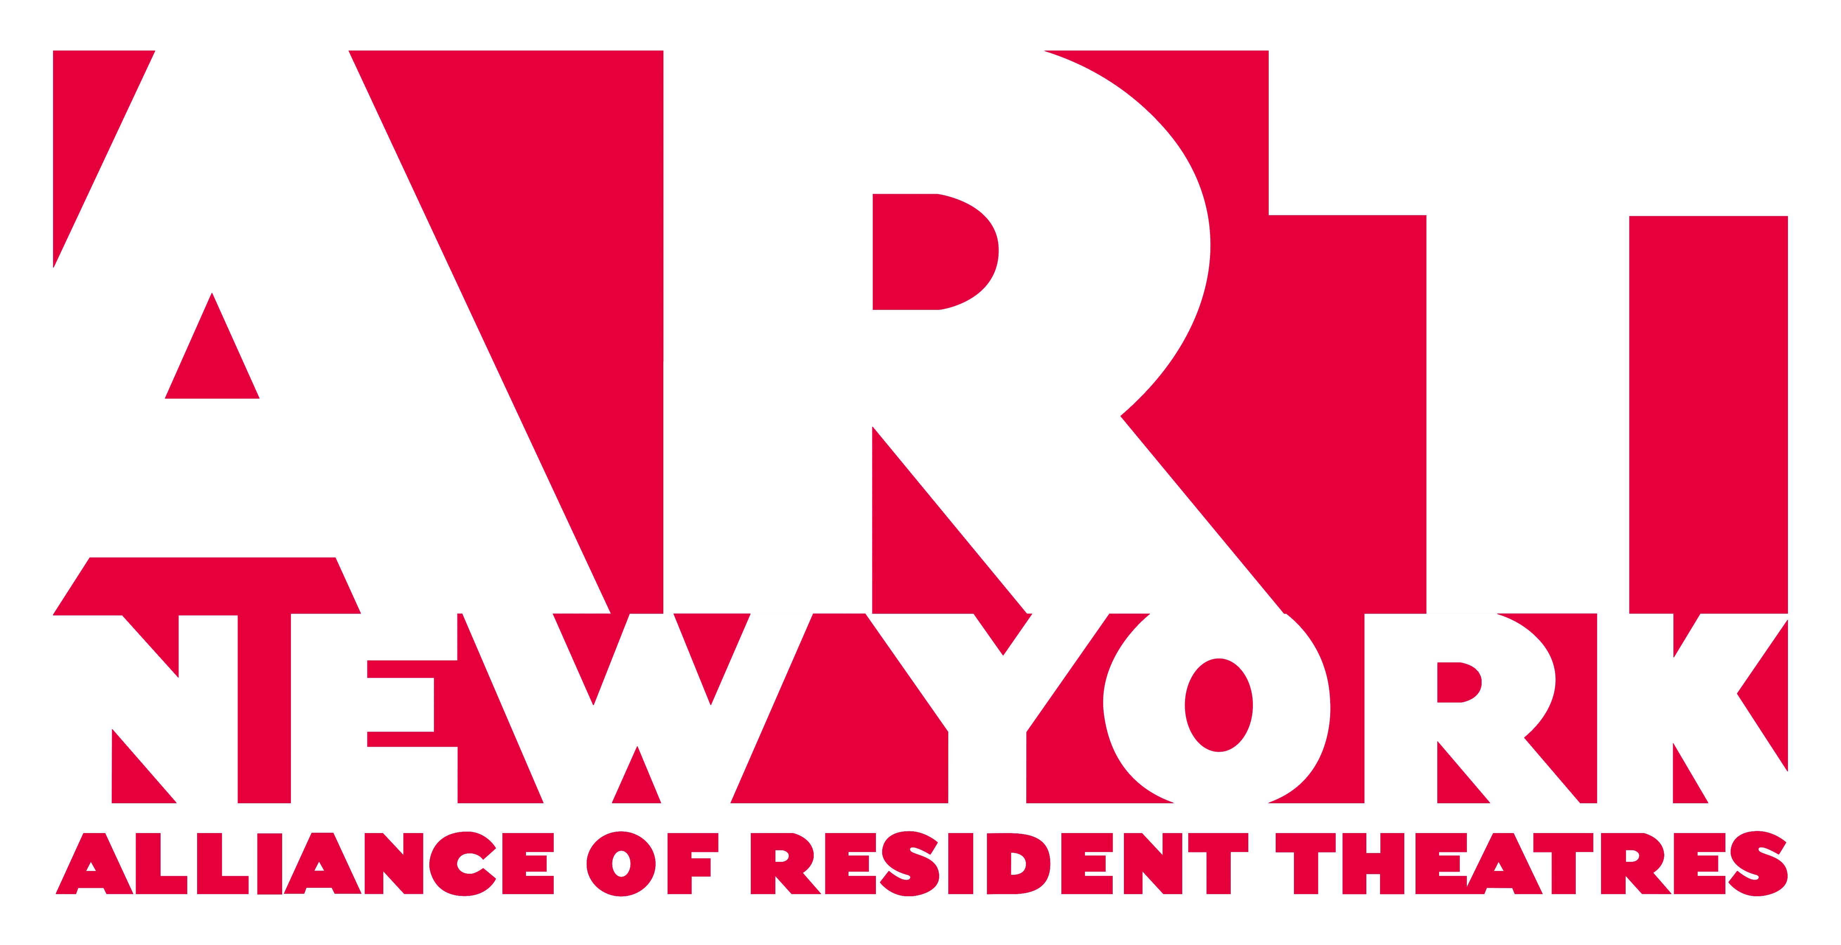
EQUIPMENT AND SPECIFICATIONS -- MEZZANINE THEATRE
Current as of October 18, 2019

INCLUDED EQUIPMENT

** The equipment specifications and inventory provided below is subject to change before the start of your rental, but will remain in comparable quantities and capabilities as listed here. The most current specs will be provided by the PM/TD no later than six (6) weeks prior to the start of your rental if changes have been made. **

LIGHTING
Control: ETC Ion

Dimming: (12) Strand S-21 dimmer sticks with (6) x 1.2k or (3) x 2.4k dimmers per stick (installed)

Fixtures: (8) ETC Source Four 26°, 575w
(28) ETC Source Four 36°, 575w
(12) ETC Source Four 50°, 575w
(12) ETC PAR, with lenses, 575w
(20) ETC D60 VIVID PAR (VNSP, MFL, WFL round lens for each)
(16) ETC S4LED Ellipsoidal with 36° lens
(6) ChromaQ72” RGBA LED Striplight
(14) GDS BlueBeam 10 deg with K2 lamp for running lights

Accessories: One C-clamp, color frame and safety cable per fixture
(12) Top hat, 6.25”
(12) Top hat, 7.5”
(20) Top hat, D60
(12) Half hat, 6.25”
(24) Donut, 6.25”
(2) Drop in iris
(12) Template holder, size A
(12) Template holder, size B
(10) 18” side arm, with tee
(20) 12” side arm, with tee

Cable: (10) Stage pin two-fer
(10) Stage pin three-fer
(20) 5’ stage pin cable
(20) 10’ stage pin cable
(15) 25’ stage pin cable
(8) 50’ stage pin cable
(45) 10’ 5-pin DMX cable
(8) 25’ 5-pin DMX cable
(8) 50’ 5-pin DMX cable
(5) 10’ L21-20 cable (installed with dimmer sticks)

House & Aisle Lighting:
Riser steps have built-in LED lights which plug directly into a wall outlet and must remain on at all times.

The theatre work lights are dimmable fluorescents and can be board controlled. Individual fixture control is not available at this time. These lights may be used for house lighting if desired. Otherwise, fixtures for house and aisle lighting must be planned for within your plot.

AUDIO
Console: Yamaha QL-5

Cabinets: (2) UPJ-1P Speakers
(6) Meyer UP Junior Speakers
(2) Meyer UMS-1P Subwoofers
(2) Meyer UM-100P Stage Monitors

Playback & Processing:
(2) MacMini (3GHz I7 processor, 8 GB RAM, Intel Iris video card) with Q-Lab pro bundle
and Dante Virtual Sound Card
(2) Denon CD players
(1) iConnectivity MIDI4+ (connected to Mac 1)
(1) Roland UM-ONE USB to MIDI (connected to Mac 2)
(2) 15’ MIDI Cable (installed)
(2) 5’ MIDI Cable (installed)

Microphones: (1) Shure SM58 wired mic
(8) Channel Shure ULXD4 wireless receivers
(2) ULXD2 handhelds with SM 58 capsules
(6) ULXD1 beltpacks for lavaliers
Lavaliers and additional handheld capsules are listed below under “Shared Equipment”

Cable: (15) 5’ XLR cable
(20) 15’ XLR cable
(30) 25’ XLR cable
(20) 50’ XLR cable
(10) 75’ XLR cable
(8) 100’ XLR cable

VIDEO
Projectors: (2) Panasonic PT-DZ10KU
(1) ET-D75LE20 lens
(1) ET-D75LE6 lens
(1) ET-D75LE50 lens

Playback: (1) Bluray player
The two MacMinis with Q-Lab pro bundle listed under Audio may also be used for video playback. One of the two is also equipped with Isadora.

Convertors: (1) Matrox Triple Head 2 GO
(2) Kanex Pro HDMI extender over Cat 6

COMMUNICATION / MONITORS
Com: (5) FS11-BP19-X4 Free Speak II Belt Packs
(1) AC60 Free Speak 5-way Charger
(5) BAT60 Free Speak II Battery
(1) MS-704 4-Channel Wired Main Station
(2) KB-702GM 2-Channel Wall Plate in dressing rooms
(10) RS-703 2-Channel Wired Belt Pack for MS-704
(10) CC-300 Single Ear Headset
(4) CC-26K-X4 Lightweight Single Ear Headset
(1) TWC-701 for dual channel wired com (installed on A and B channels)

Program: Program mic feed is programmable to backstage, dressing rooms and front-of-house via the building’s paging system.

Video Camera: Vaddio Roboshot 30HD-SDI is available and can be routed to existing TVs in lobby to assist with late seating.

Infrared Camera: Bosch VTI4085-V521 is available; company will be responsible for setup.

Assistive Listening Devices:
The Mezzanine Theatre is outfitted with a FM assistive listening system.
(10) Receivers with (10) headsets and (6) neck loops are available.

POWER
(25) L21-20 outlets are located throughout the theatre to power the S-21 dimmer sticks both at grid height and at stage level. Please see drawing for exact locations.

(1) 200-Amp 3-phase company switch located in mechanical catwalk. Please notify A.R.T./New York if you will be using the company switch.

20-Amp Edison-style outlets are located throughout the theatre and lobby, both at grid height and at stage level. Please see drawings for exact locations and circuit numbers.

SOFT GOODS
(4) 22’-0” x 11’-10” Traveler Panel, Black Velour, 70% Fullness (2 Track)
(2) 16’-6” x 13’-3” Black Velour Panel, Sewn Flat
(8) 7’-6” x 13’-3” Legs, Black Velour, Sewn Flat
(1) 44’-0” x 13’-3” Cyc, White Leno Filled Scrim
(1) 44’-0” x 13’-3” Sharkstooth Scrim, Black
(1) 44’-0” x 13’-3” Sharkstooth Scrim, White
(14) 7’-6” x 11’-10” additional masking panels (on installed track; can be repurposed and relocated only with prior approval by A.R.T./New York’s PM/TD)
Perimeter Black Velour Panels to cover windows (on installed track, may not be removed)
Storage Bags or hampers available for all drapes

OTHER
Tech tables: (2) tech tables will be provided, with (3) LittlLites per table.
Prop tables: A limited number of folding tables are available, please ask A.R.T./New York staff.
Cleaning: Broom, dustpan, dust mop, mop and bucket, and shop vacuum.

Items that are the responsibility of the company:
Scenic and properties stocks; hardware (e.g. screws, hinges, etc.); perishables (including but not limited to color media and gaffer’s tape); extension cords and power strips; etc.

SHARED EQUIPMENT LIST

** All subject to availability and must be reserved in advance **

LIGHTING
(5) Strand S-21 dimmer sticks with (6) x 1.2k or (3) x 2.4k dimmers per stick
(5) ChromaQ 72” RGBA LED striplight,
(28) 19° ETC Source Four standard lens
(13) 26° ETC Source Four standard lens
(31) 36° ETC Source Four standard lens
(8) 50° ETC Source Four standard lens
(65) Power con to male Edison cable
(15) 5’ Power con feed thru cable
(15) 10’ Power con feed thru cable
(15) 25’ Power con feed thru cable
(28) Power con to male Stage Pin
(15) 25’ Edison
(15) 50’ Edison
(15) 100’ Edison
(5) FED adapters
(12) 10’ Cat 6 Ethernet cable
(24) 25’ Cat 6 Ethernet cable
(8) 50’ Cat 6 Ethernet cable
(5) 25’ L21-20 cable (for use with dimmer sticks)
(2) L21-20 distribution box with (3) 20amp switched stage pin outlets
(3) Single 20amp edison distribution box with (3) switched stage pin outlets for use with cue lights
(7) ETC Net3 2 universe touring gateway
(12) 50 lb boom base
(14) 6’ threaded 1.5” pipe
(3) 8’ threaded 1.5” pipe
(4) 10’ threaded 1.5” pipe
(1) 21’-8” ADC Silent Steel 280 track
(1) 20’ ADC Silent Steel 280 track
(2) 19’ ADC Silent Steel 280 track
(4) 10’ ADC Silent Steel 280 Track
(3) ADC Splice Clamps
(3) ADC Live End Pulley
(3) ADC Dead End Pulley
(3) ADC Adjustable Floor Pulley
Inventory of Master and Single carriers, hanging clamps, and batten clamps for use with track

AUDIO
(6) Shure WL93 lavalier
(2) Countryman B2D lavalier
(12) Countryman B3 lavalier
(2) Shure KSM9 Handheld capsule
(8) Shure SM57 instrument mic
(6) Shure SM58 vocal mic
(2) AKG 414XLII condenser mic
(2) AKG D112 bass drum mic
(7) Radial Pro DI passive direct box
(9) Round base mic stands
(10) Tripod mic stand with boom
(2) 15’ MIDI Cable
(2) 5’ MIDI Cable
(8) Shure WA580B Pouch for wireless belt pack

VIDEO
All video screens are shared between theatres and are available on a first-come, first-served basis. If you require video for your production, please submit your screen and lens needs to the A.R.T./New York PM/TD as soon as they are known.

(10) 10’ SDI cable
(12) 25’ SDI cable
(6) 50’ SDI cable
(2) AV Stumpfl 16’-0” x 9’-0” fast fold screen kit
(2) AV Stumpfl 10’-0” x 7’-6” fast fold screen kit
(2) AV Stumpfl 8’-9” x 4’-11” fast fold screen kit
(1) Vaddio Roboshot 30HD-SDI with ProductionVIEW precision camera controller

SOFT GOODS
(4) 7’-6” x 13’-6” Legs, Black Velour, Sewn Flat
(4) 38’-0” x 2’-6” Borders, Black Velour

BUILDING INVENTORY (subject to availability)

Ladders: (2) 6’ step ladder
(1) 8’ step ladder
(2) 10’ step ladder
(1) 12’ step ladder
(1) AWP-20 Genie

MEZZANINE THEATRE SPECIFICATIONS

** All measurements based off of architectural drawings. These will be verified onsite over time. **

ROOM DIMENSIONS
- 52’-9” depth (booth to windows) x 59’-3” wide, with one cement column towards the center of the room.
- Stage size varies depending on seating configuration. There are fourteen approved seating configurations.

STAGE FLOOR
- Masonite over three layers of plywood, painted black.

GRID STRUCTURE
- Dead hung pipe grid at 13’-5” with pipe spaced at 5’ on center.

WINDOWS AND SHADES
- The windows on the exterior walls of theatre have been equipped with full blackout and partial blackout shades. All shades are manual pull.

UNISTRUT
- Unistrut is mounted vertically in the perimeter walls at various spacings (typically 4’ on center). When perimeter velour panels are in use, some unistrut may not be accessible.

BOOTH
- Booth is equipped with windows overlooking the theatre with half the panes able to be opened
- TV monitor located in booth for use as a stage monitor, Decimator DMON-QUAD installed for multiview
- Lockable safe for valuables is located in the booth.
- Booth layout cannot be rearranged without approval by A.R.T./New York staff.

PLANS AVAILABLE
- Ground plans, sections, grid plans in VWX, DWG, and PDF format.
- We recommend that you do your own site survey

DRESSING ROOMS
There are two ADA-compliant dressing rooms accommodating up to 4-6 people each. Each is equipped with a counter, chairs, mirrors, one wardrobe rack, one Equity cot, and audio stage monitors. Each dressing room has a toilet room with a sink and shower inside.

BACKSTAGE
There is a “green room hallway” outside of the dressing rooms with counter space and cabinets, and equipped with a mini fridge and a small microwave. All coffee/tea supplies, disposable dishes, and other perishables must be furnished by the company. A call board is available backstage near the dressing rooms.

LAUNDRY
A shared laundry area is located in the Mezzanine Theatre. The laundry area is equipped with two washers & dryers, one iron and ironing board, and one steamer. All equipment is shared with both theatres, and laundry schedules must be coordinated with A.R.T./New York. The company must provide all laundry detergent, hangers, costume maintenance equipment and materials needed for the production. These items shall be clearly labeled and kept on a designated shelf.

