End gun violence with art! Today, #NYCArtsGoOrange to stand united against gun violence in NYC. Join us & go orange http://www.gunviolenceawarenessmonth.org/
Use art not guns! Join us and go orange to stand against gun violence in New York City. #NYCArtsGoOrange http://www.gunviolenceawarenessmonth.org/
#NYCArtsGoOrange to tackle the issue of needless and senseless gun violence in New York’s communities. Join us.
#NYCArtsGoOrange to raise awareness about gun violence in order to make our communities safe places for everyone.
June is Anti-Gun Violence Awareness Month. We’re proud to stand with #NYCArtsGoOrange to combat this scourge on our communities.

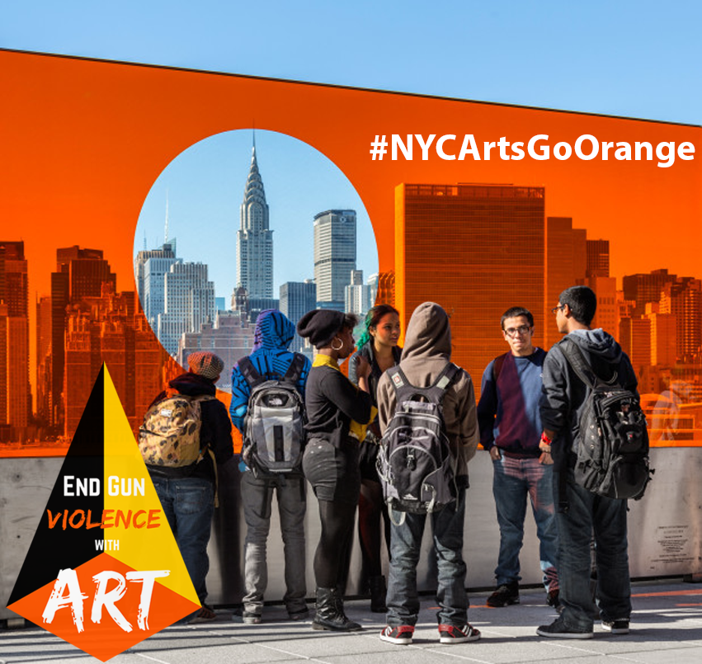
Photo: Natasha Johns-Messenger, 'Alterview,' Percent for Art commission for the 5th floor terrace of the new FXFOWLE-designed Hunter’s Point campus in Queens.

